■ Atmosic ATM2 build & debug Guide
- Install Atmosic SDK 5.4.0.1
  - Run AtmosicSDK_Inst_5.4.0.1
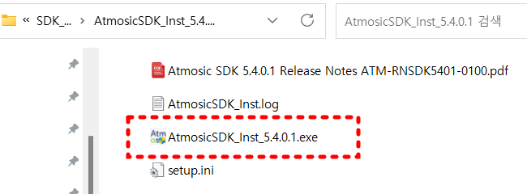
  - Agree with License Agreement.
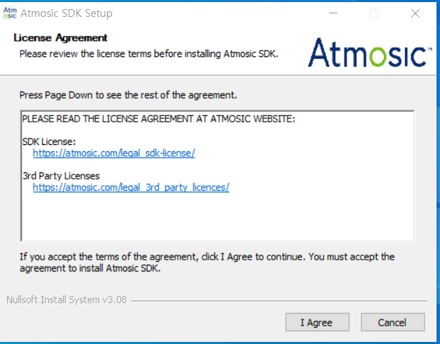
  - Install with default destination Folder. (Do not use Korean Langunage.)
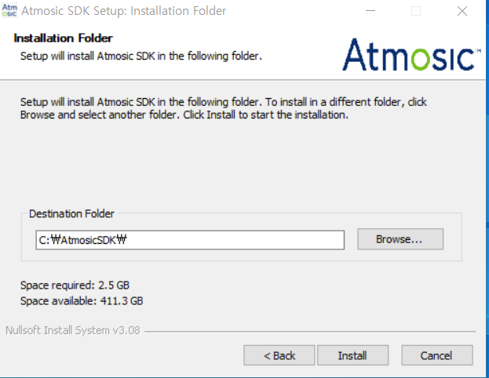
  - Please wait while Atmosic SDK is being installed. (It takes several minutes.)
  - Install completed.
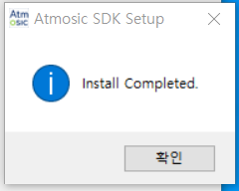

- Install J-link software pack
  - Run “Jlink_Windows_V784c_i386.exe (Download from https://www.segger.com/downloads/jlink/JLink_Windows.exe )
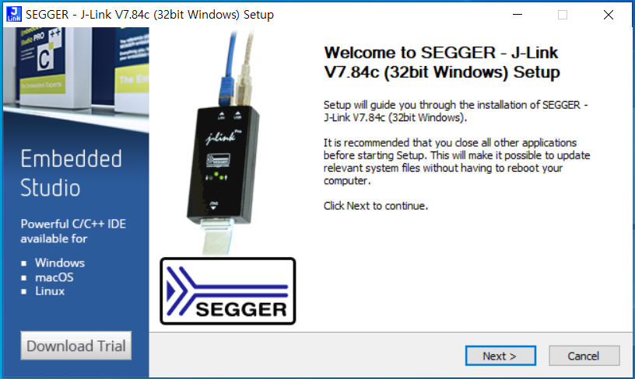
  - License agreement.
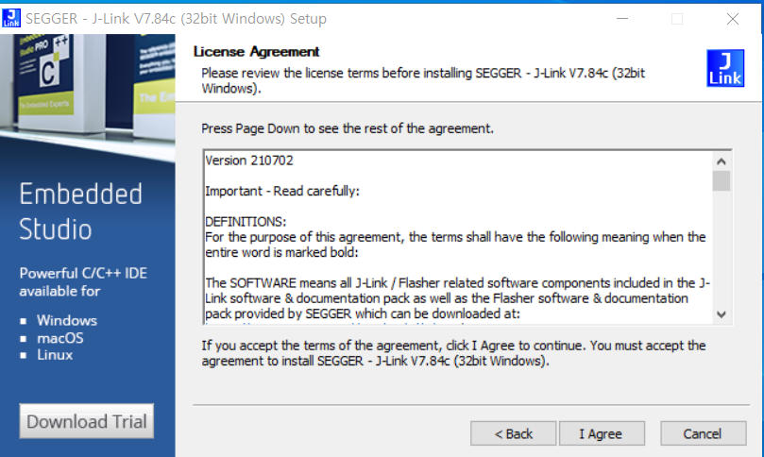
  - Install with default option.
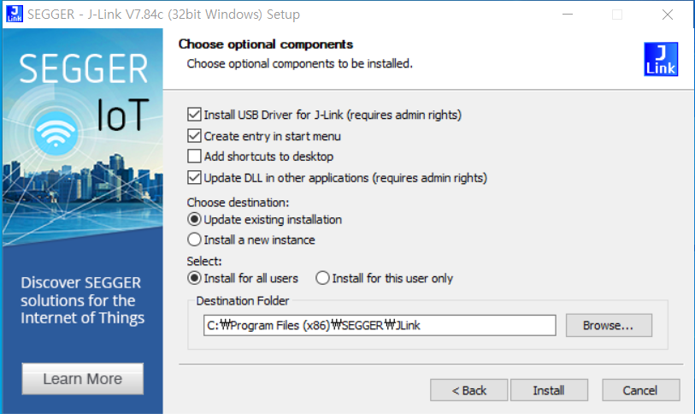

  - Finish install process.
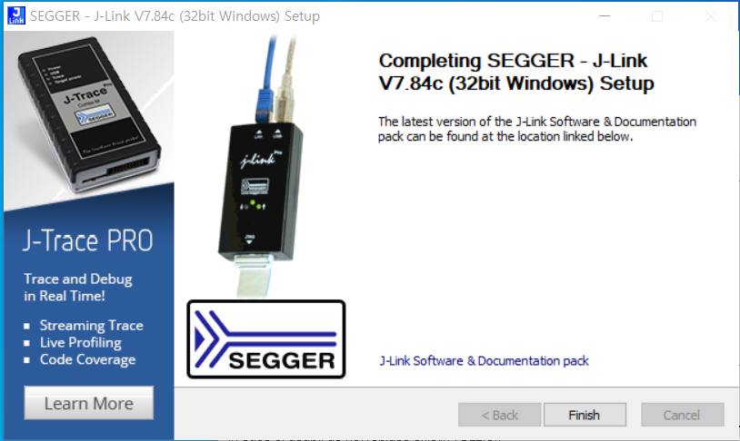
  - Click “OK” for SEGGER J-link DLL Updater V7.84c.
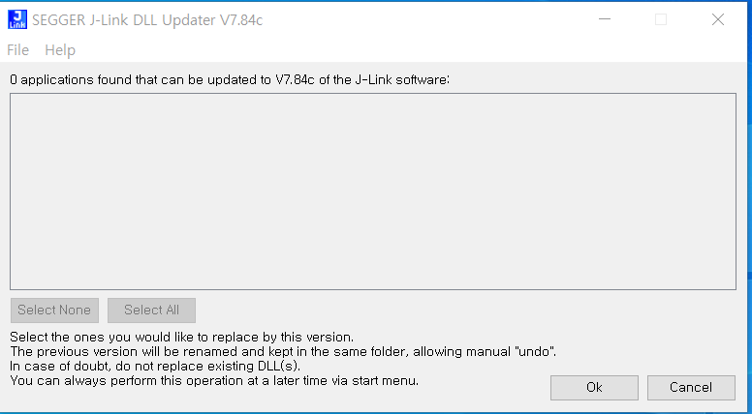

  - Connect EVK_ATM2xxx to PC through USB. After then, you can see below driver from Device Manage in Windows. (See below)
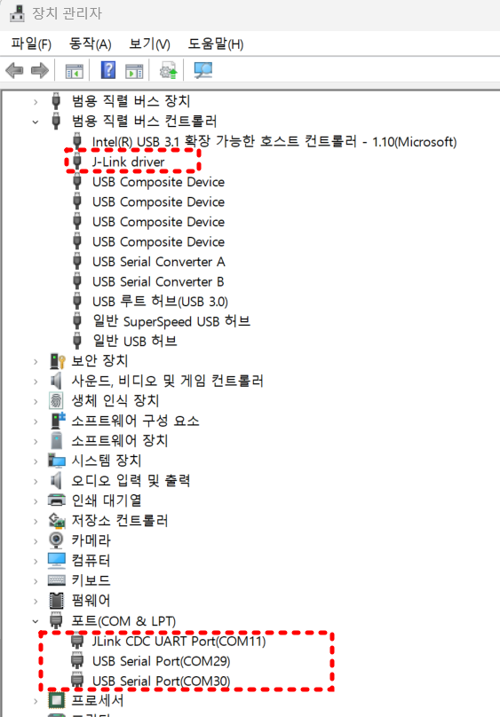
  - Run “Setup IDE Environment (5.4.0.1)” from AtmosicSDK menu.
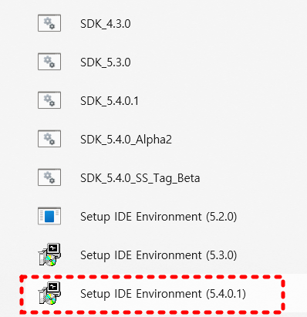
  - Reboot computer to apply setting.
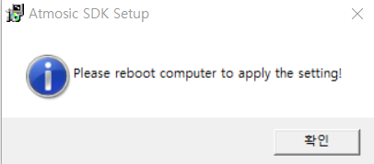

- Install Segger Embedded Studio.
  - Please download SES package from below link.
https://www.segger.com/products/development-tools/embedded-studio/
  - Click “List of downloads” on the right side of screen.
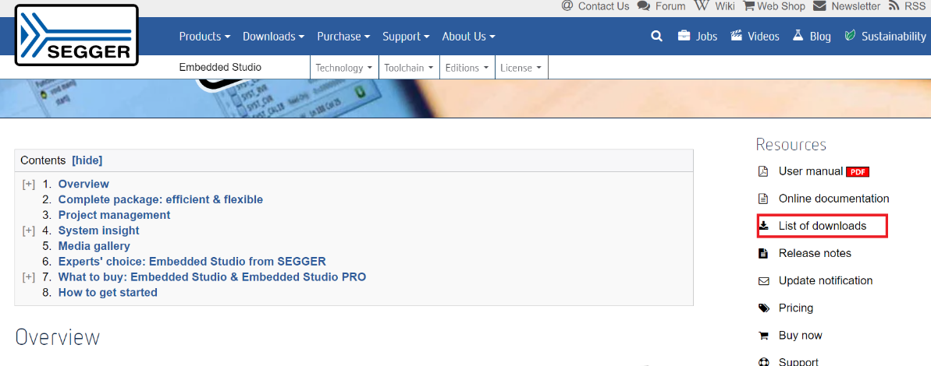
  - Select version as V6.22a and click 64-bit installer on screen. (V7.10a)
=> 아래 설명은 7.1로 되어 있음. 최신 것으로 해도 될 수도…확인해 볼것.
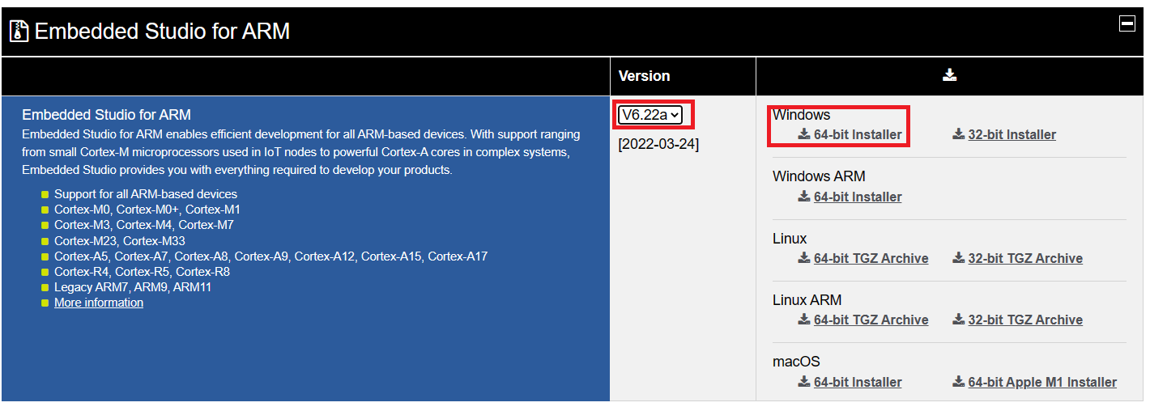

  - Click “Download”
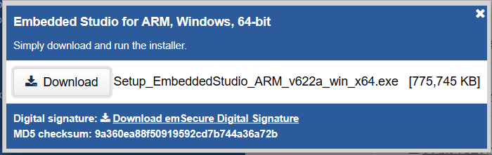
  - You can see below package file.
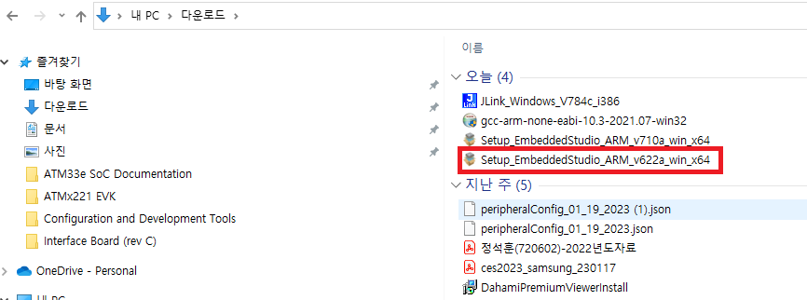
  - Install “SES package” by run “Setup_EmbeddedStudio_ARM_v622a_win_x64.exe”
  - Use default option. (Installation process will takes several minutes depends on your PC.)
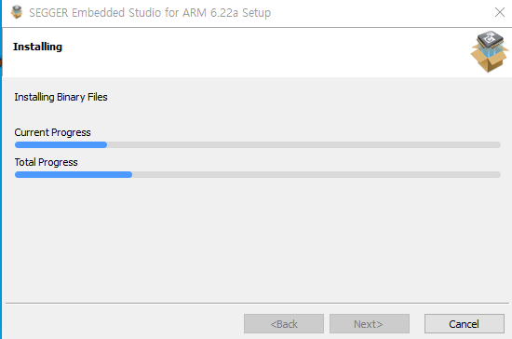
  - Install complete.
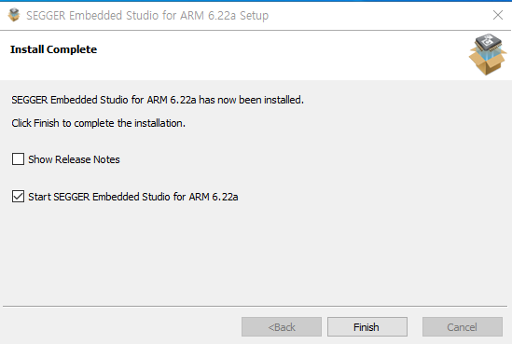
  - Run Segger Embedded studio, you can see below screen and Accept License agreement.
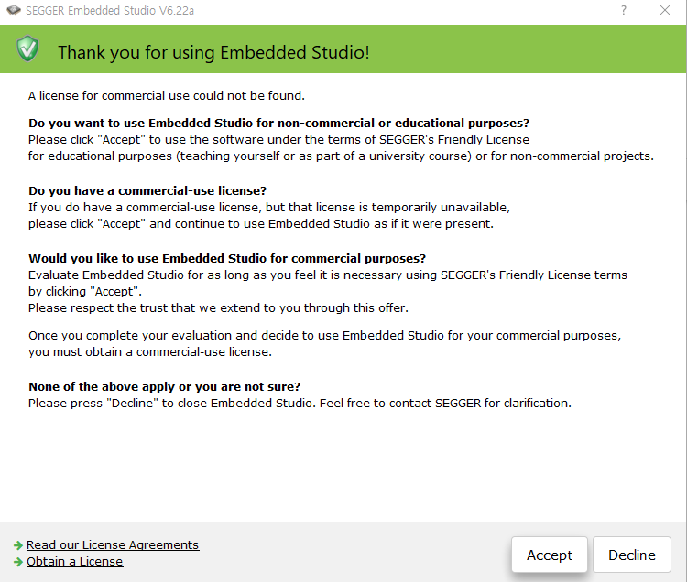
  - After run SES, you can see “Hello” example as following.
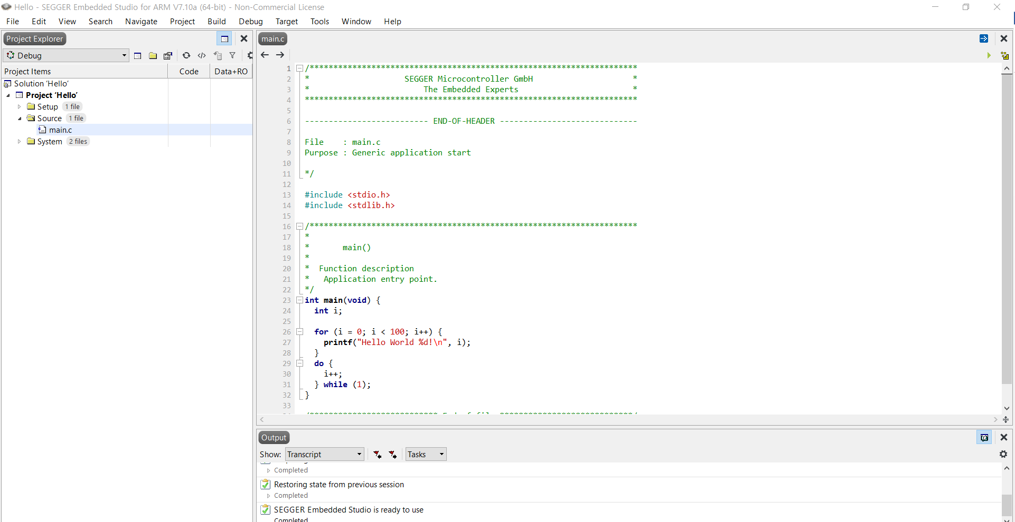
  - Close Project Explorer & code viewer by clicking “x”
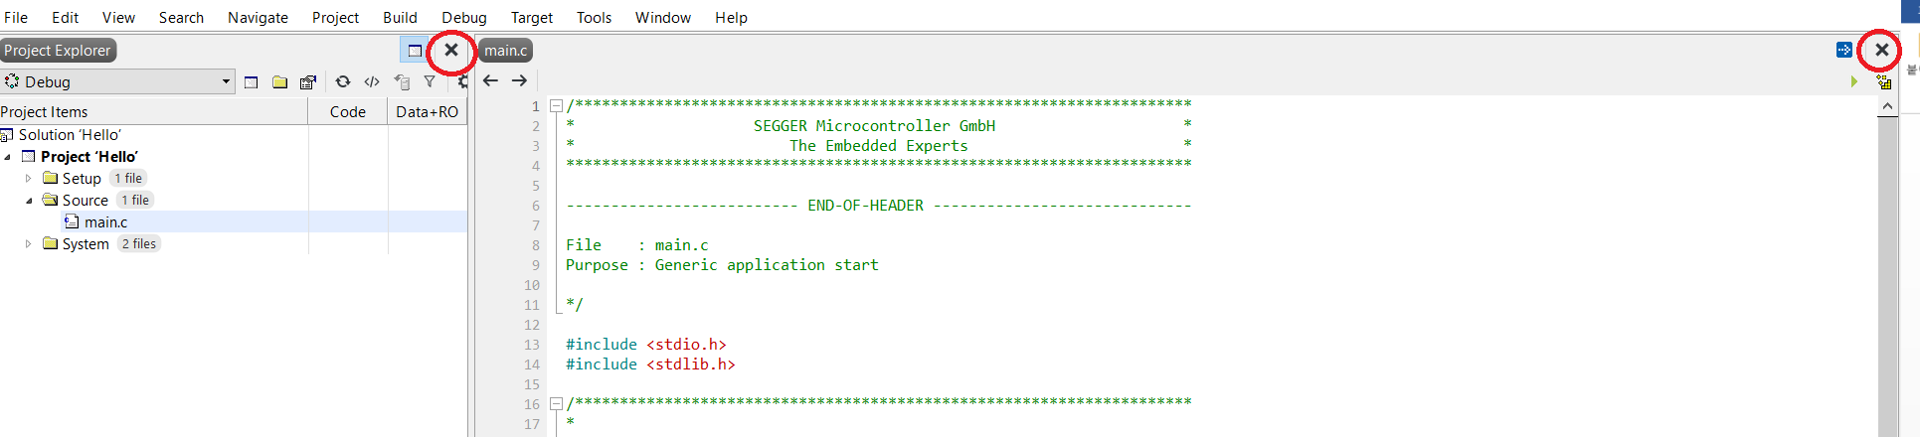
  - You can see below screen.
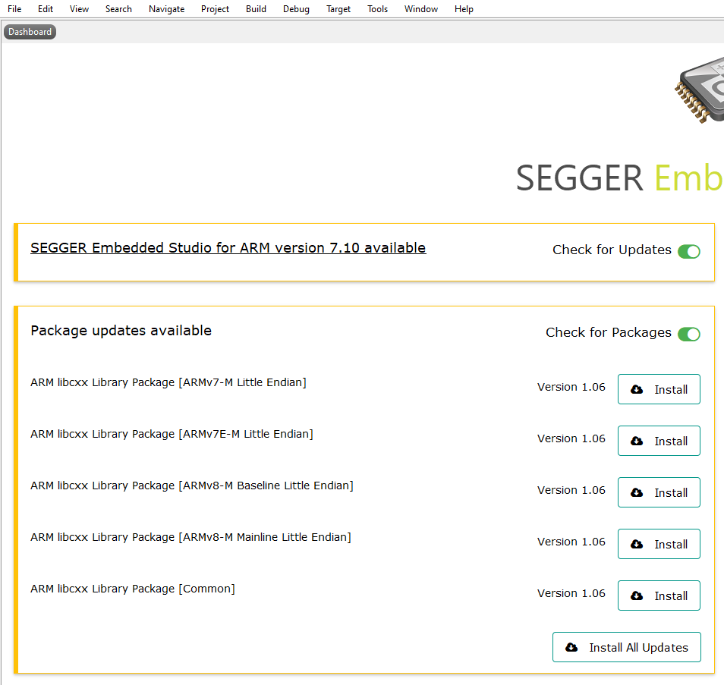
  - Select “Install All Updates” from above screen.
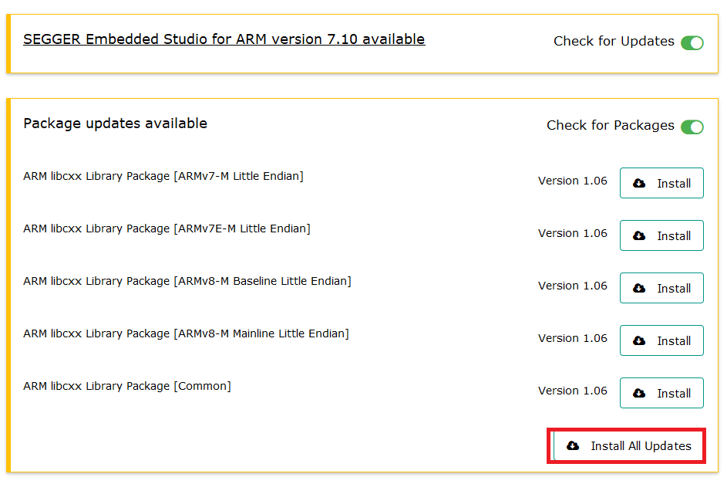
  - Click “Next”
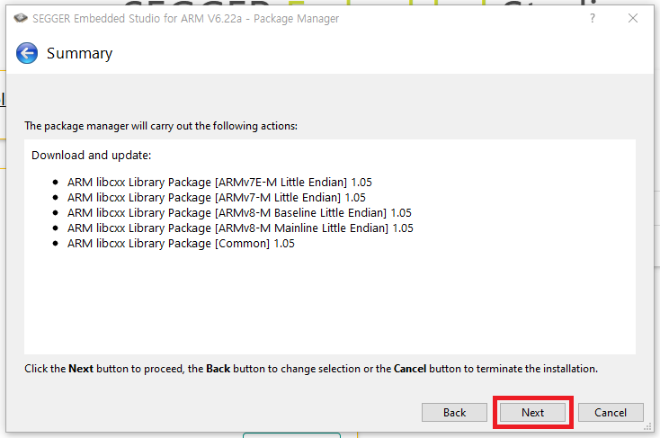

  - Update finished, and click Finish.
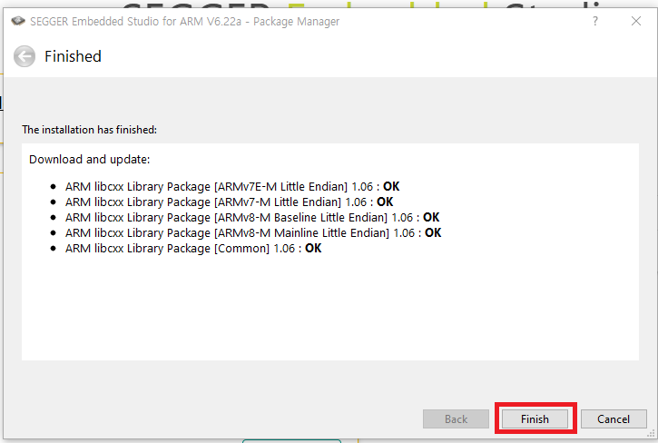
  - Close Segger Embedded Studio program.
  - Copy JLinkDevices.xml (C:\AtmosicSDK\5.4.0.1\tools\jlink) to C:\Program Files\SEGGER\SEGGER Embedded Studio for ARM 7.10a\bin.
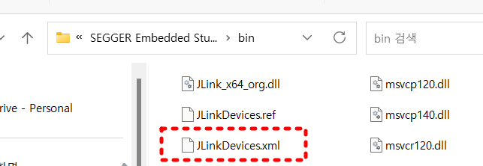
  - Create “Atmosic\ATMx2” folder under : C:\Program Files\SEGGER\SEGGER Embedded Studio for ARM 7.10a\bin\Devices
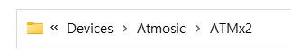
  - Copy ATMx2.FLM (C:\AtmosicSDK\5.4.0.1\tools\jlink) to C:\Program Files
\SEGGER\SEGGER Embedded Studio for ARM 7.10a\bin\Devices\Atmosic\ATMx2
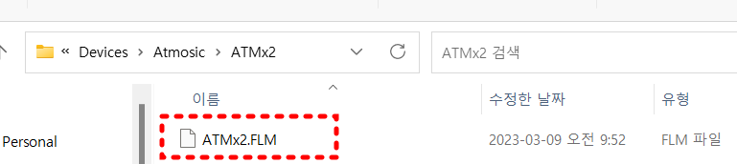
  - HW Setup.
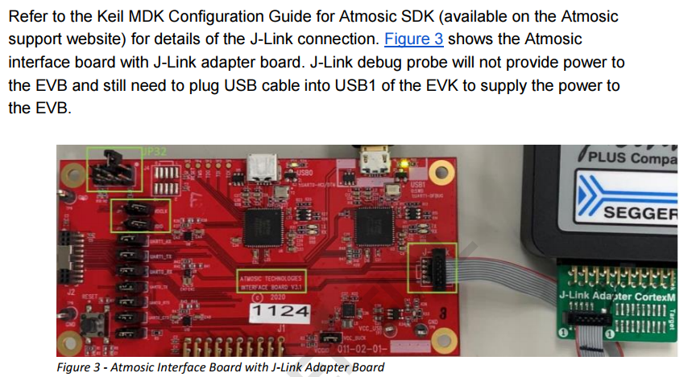

- Make SES project file from Atmosic SDK.
  - Run AtmosicSDK (SDK_5.4.0.1)
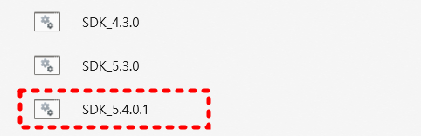
  - Change directory as following. (C:\AtmosicSDK\5.4.0.1\platform\atm2\ATM22xx-x1x\examples\BLE_adv)
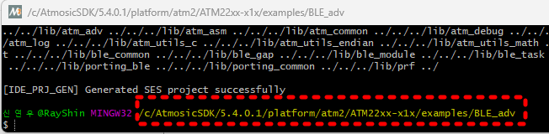
  - Run below command
make ses_gen BOARD=ATMEVK_M2202 (Settings suitable for product P/N)
=> make ses_gen BOARD=m2221

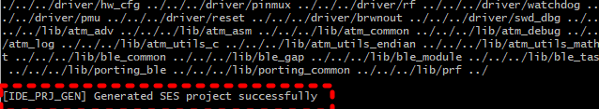
  - After finish this process, you can see generated “ses” directory.
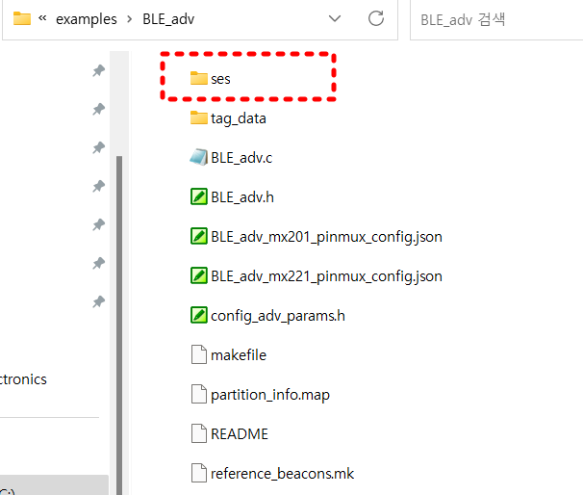
  - You can see BLE_adv.emProject file in ses directory.

- Build, Download & Debug
5-1. Download
  - Run Segger Embedded studio again from your PC.
  - After run SES, you can see “Hello” example as following.
  - Close Project Explorer & code viewer by clicking “x”
  - You can see below screen.
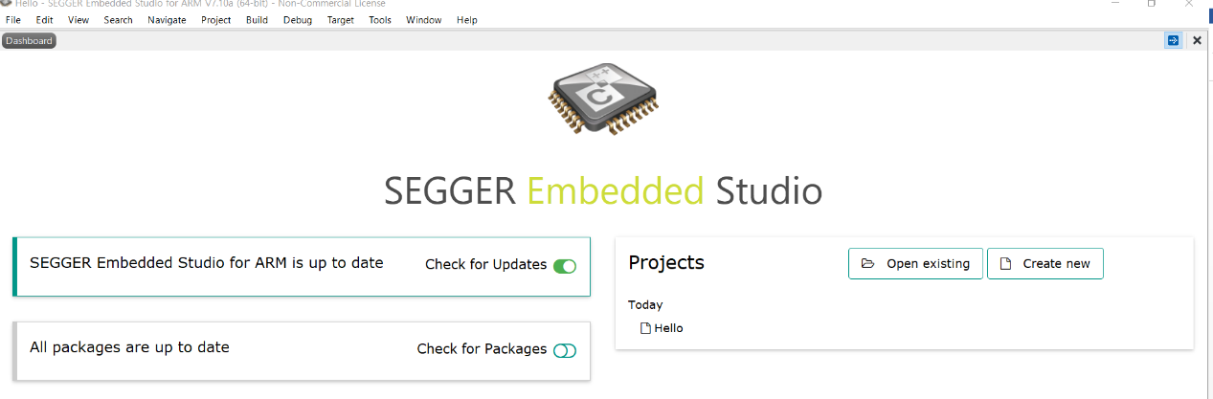

  - Click “Open existing”
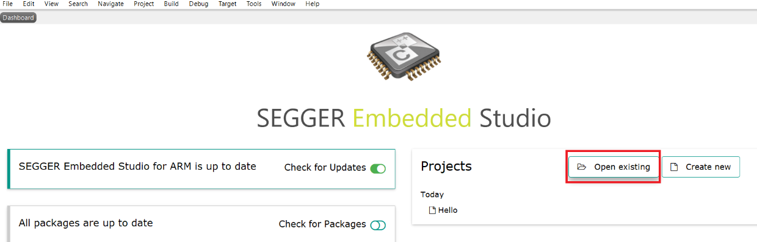
  - Choose BLE_av.emProject file from :
C:\AtmosicSDK\5.4.0.1\platform\atm2\ATM22xx-x1x\examples\BLE_adv\ses
  - Open BLE_adv
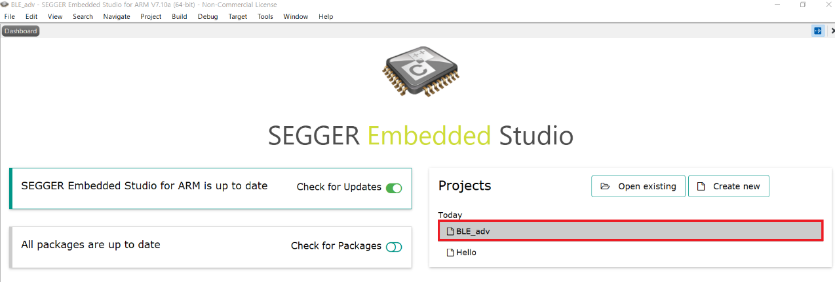
  - You can see below screen.
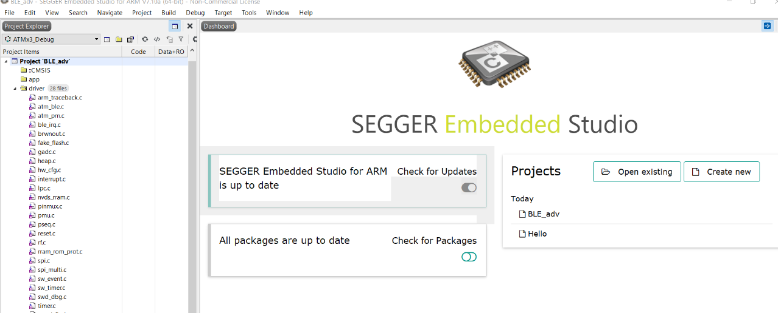

  - By double click BLE_adv.c file from Project Explorer, you can see source code on code view section.
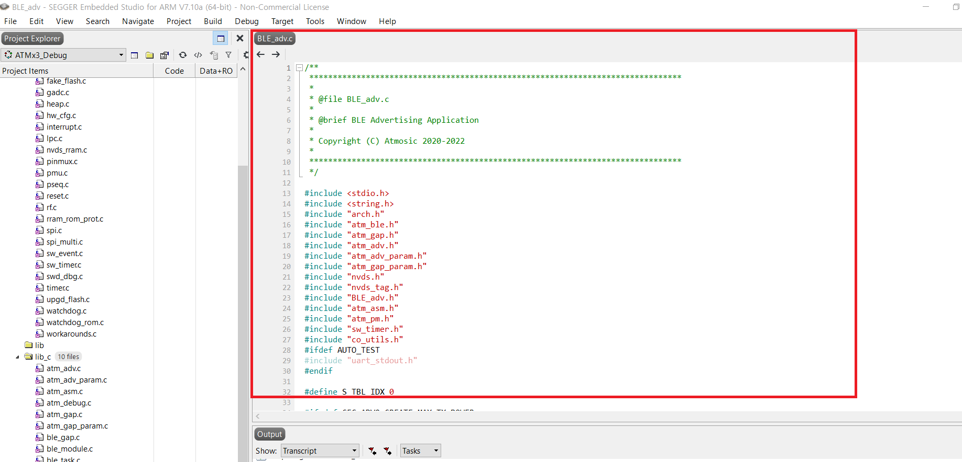
  - Set compile option
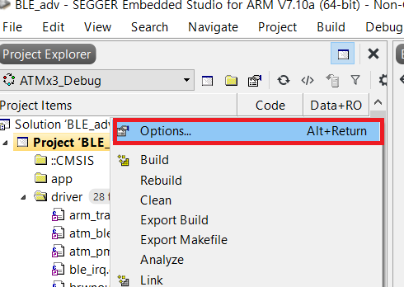
  - Click “Code” 🡪 Build 🡪 Toolchain Directory
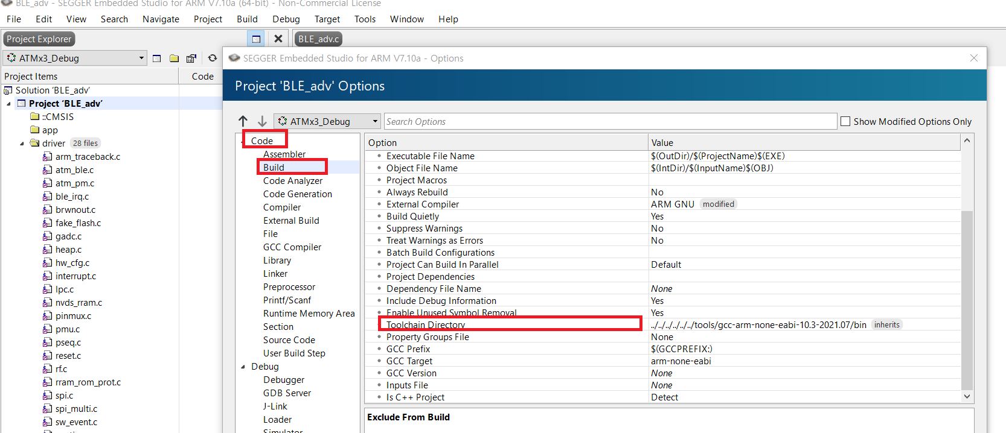
  - Change GCC tool as like following.
    - Click … icon. (See below rec mark.)
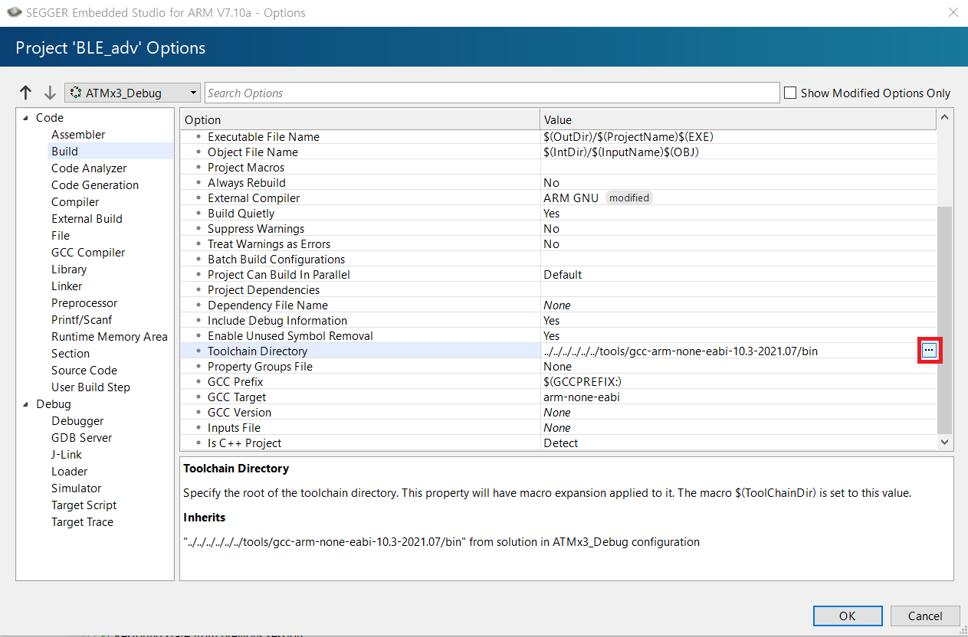
    - Please select GCC compiler directory as following.
(C:\AtmosicSDK\5.4.0.1\tools\gcc-arm-none-eabi-10.3-2021.07\bin)
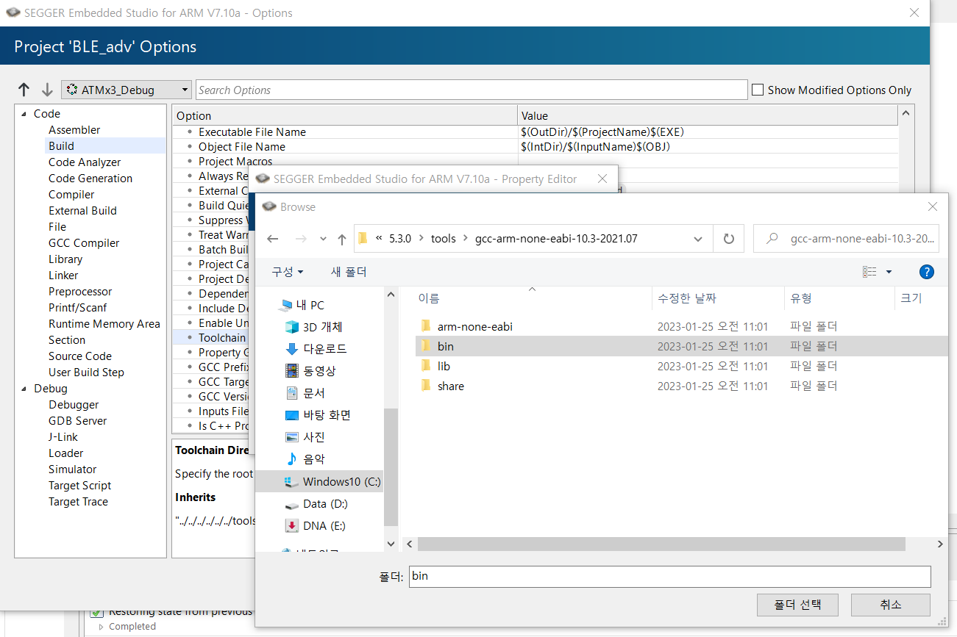
    - Select J-link 🡪 Speed option.
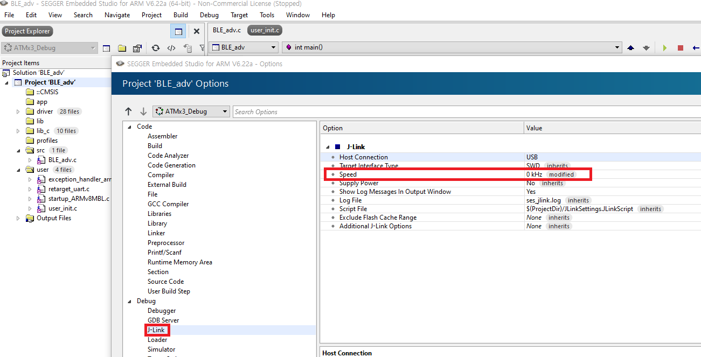
    - Set speed to 0KHz. (It means auto-detect best possible.)
    - Exit option menu by click “OK” button.
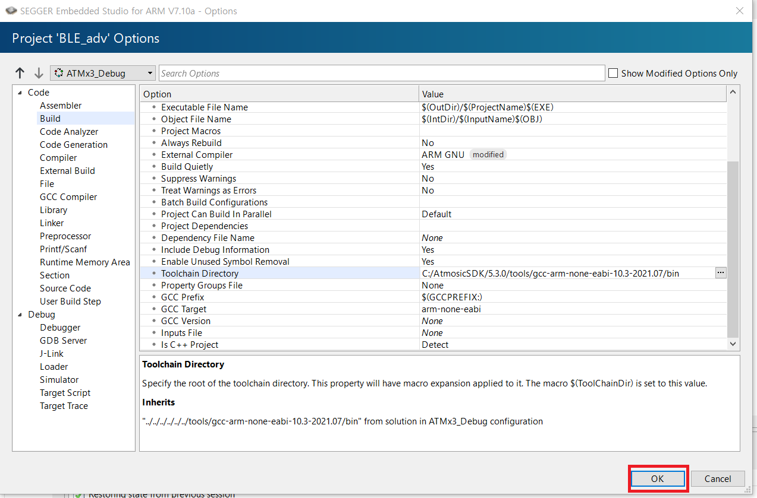
  - “Build” project by selecting “Build” 🡪 Build BLE_adv
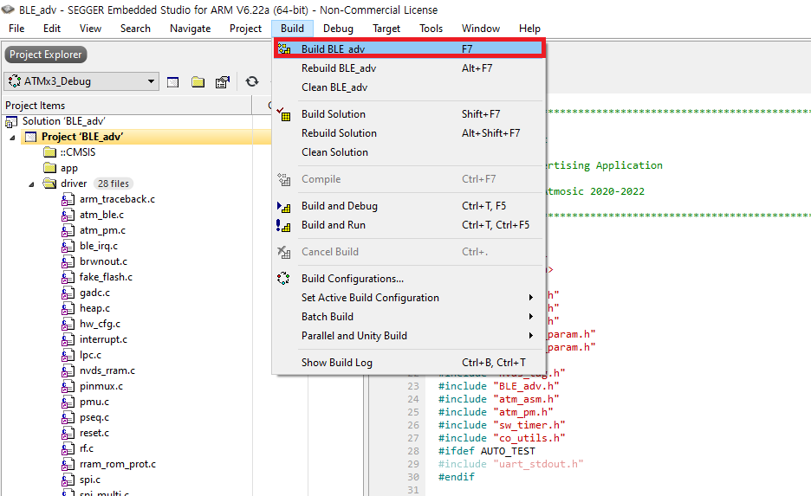
  - Build Completed.
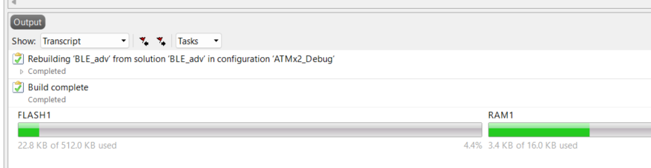
  - Connect Jlink.
Select Target 🡪 Connect J-link.
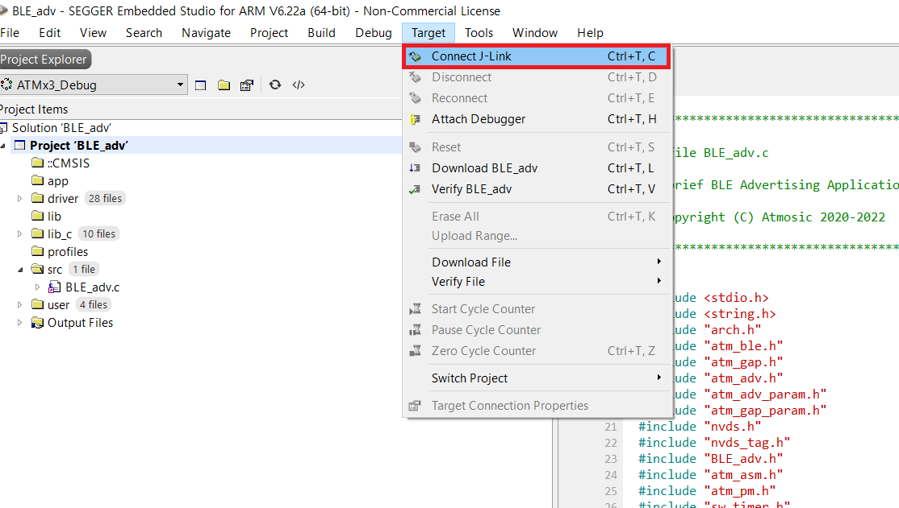

  - Connection completed.
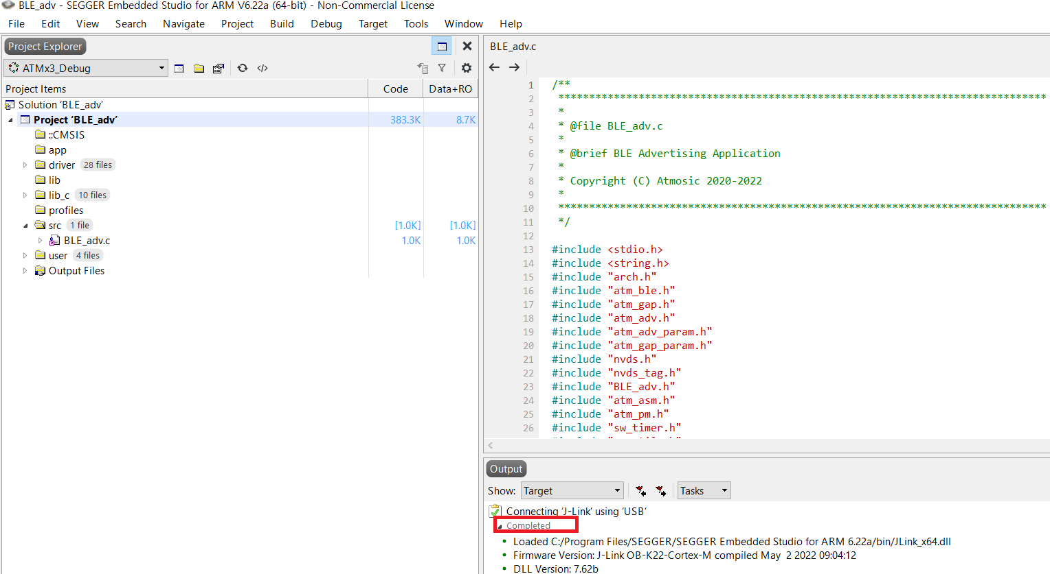
  - Download binary image into EVK.
Select Target 🡪 Download BLE_adv
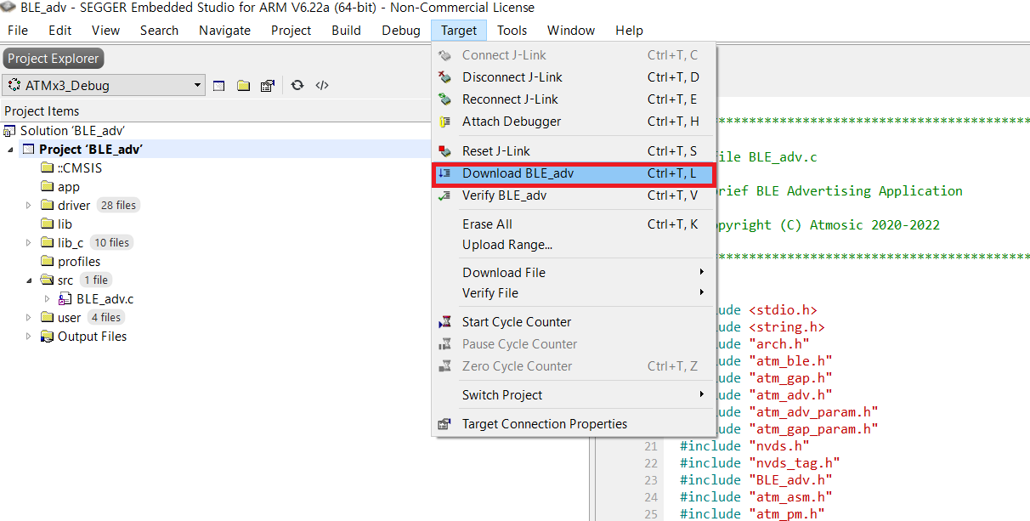

  - Completed download process.
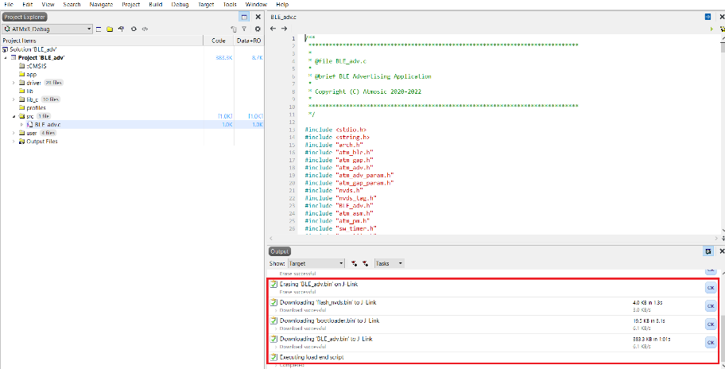

5-2. Debug
- Select Debug 🡪 Go(F5) menu to enter debug mode.
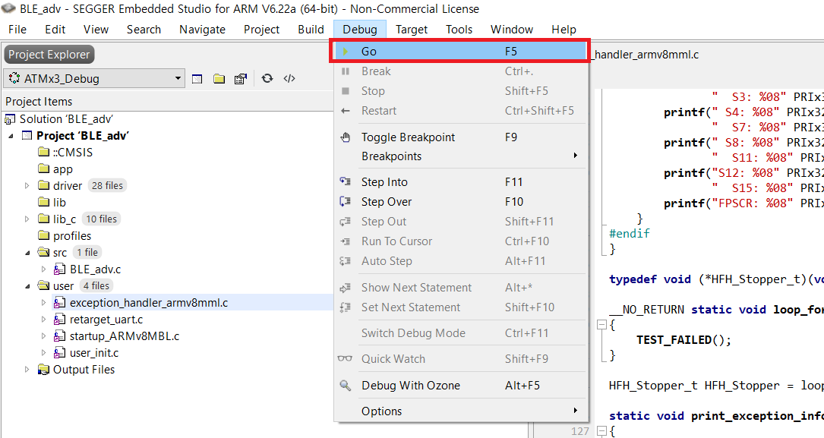
- “Flash.c” pop-up window -> cancel(취소) click -> “Can’t find source file”->Yes click
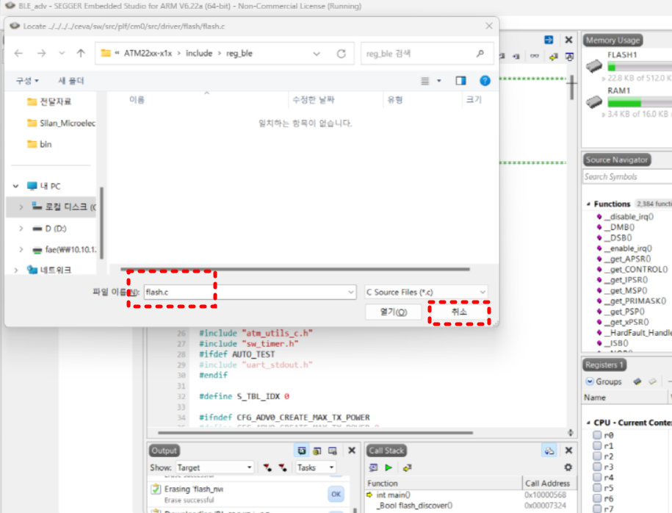
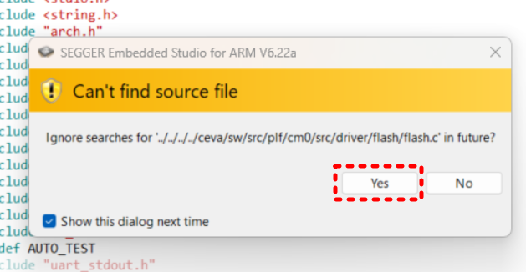
- “arch_main.c” pop-up window -> cancel(취소) click -> “Can’t find source file”->Yes click
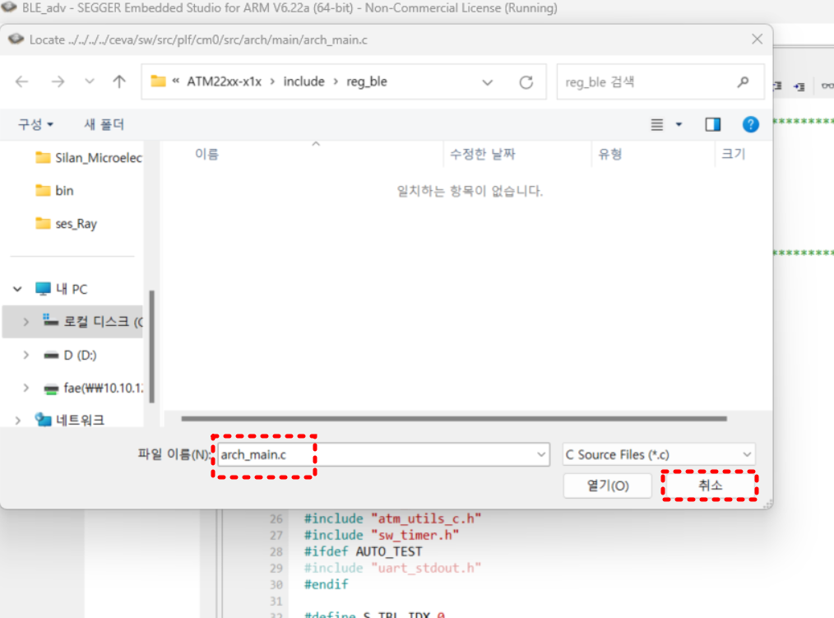
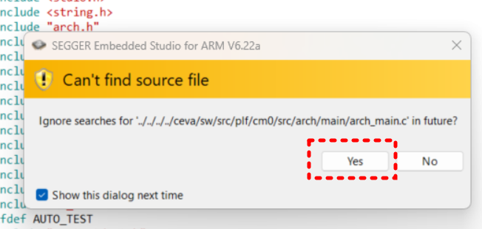
- Stop debug click(below red box)
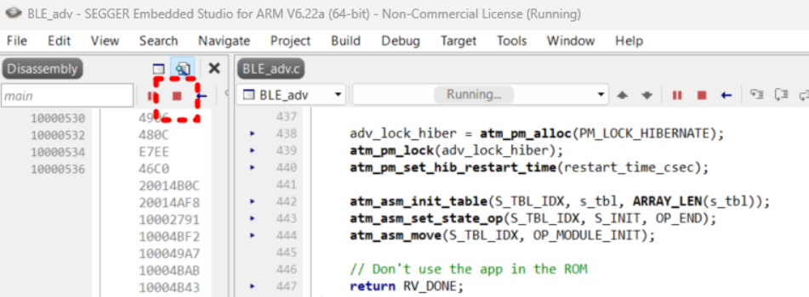

- Break point Setting(below red box) -> Select Debug 🡪 Go menu or F5 enter 🡪
Check UART log out “user_main() done”
Using the “Tera Term” program. , Check the port on your pc
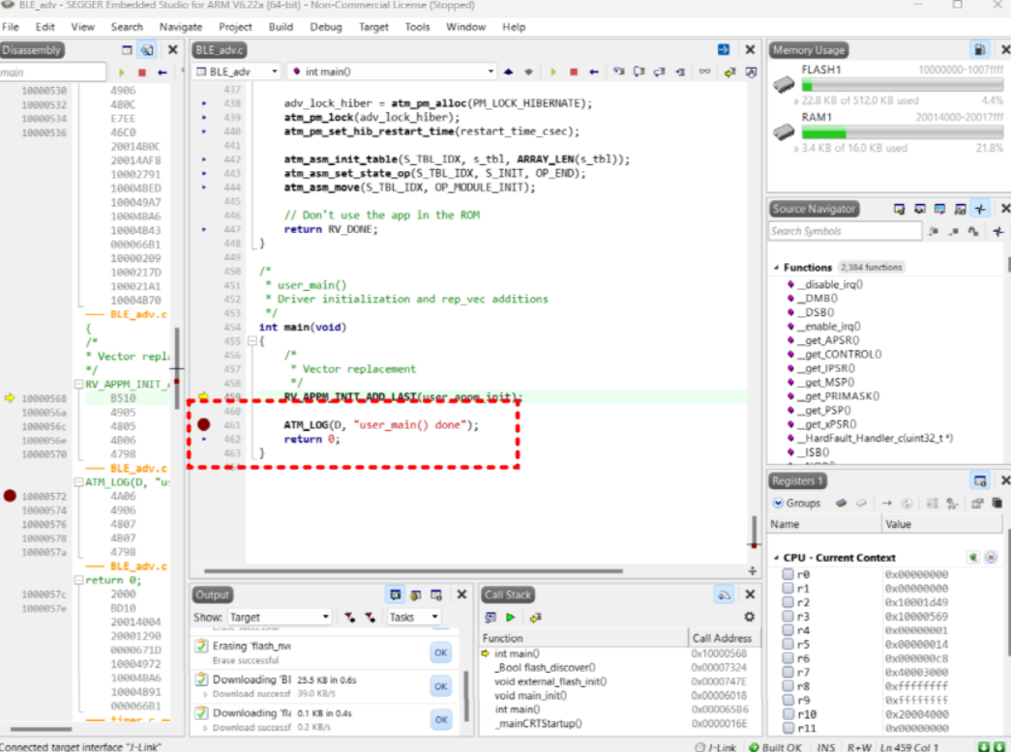
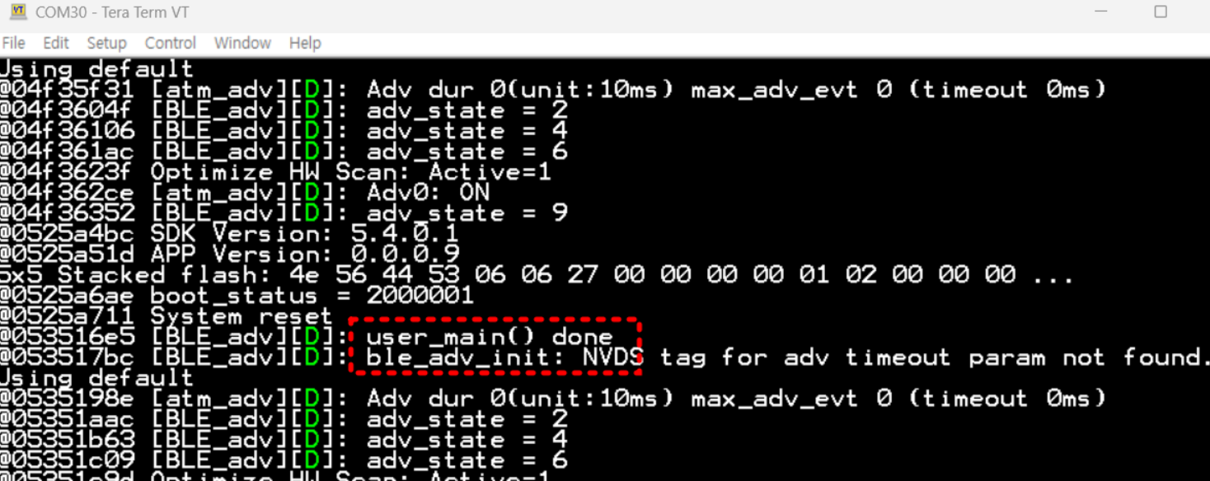

- Stop debug click and change log “user_main() done”->“user_main() done_test”
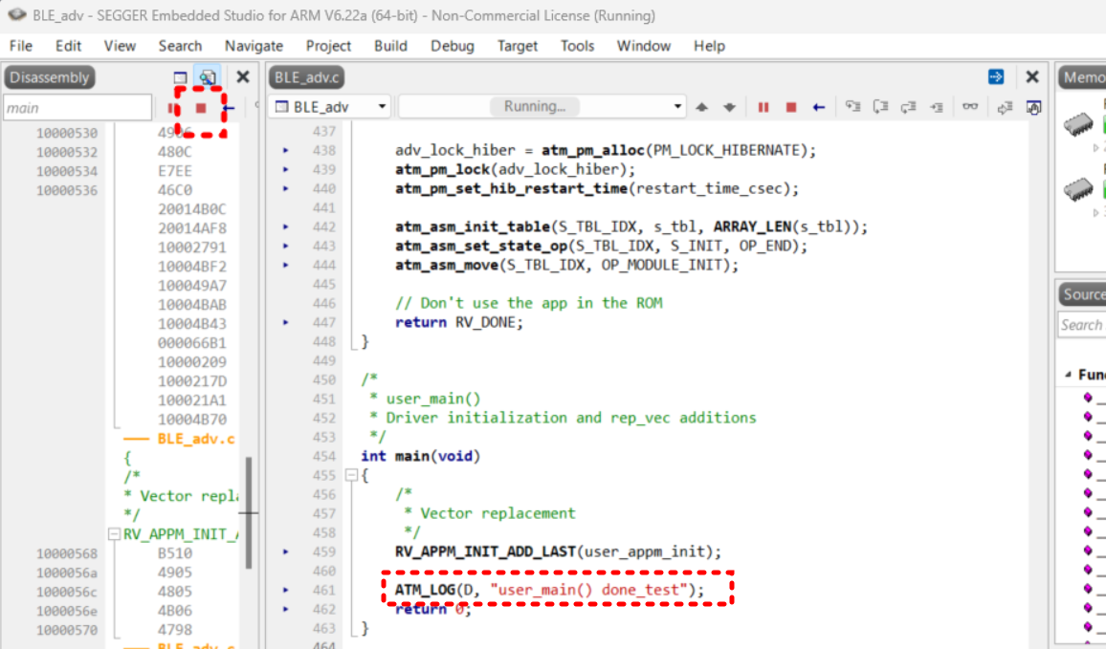
- Select Debug 🡪 Go menu or F5 enter and check UART log out “user_main() done_test”
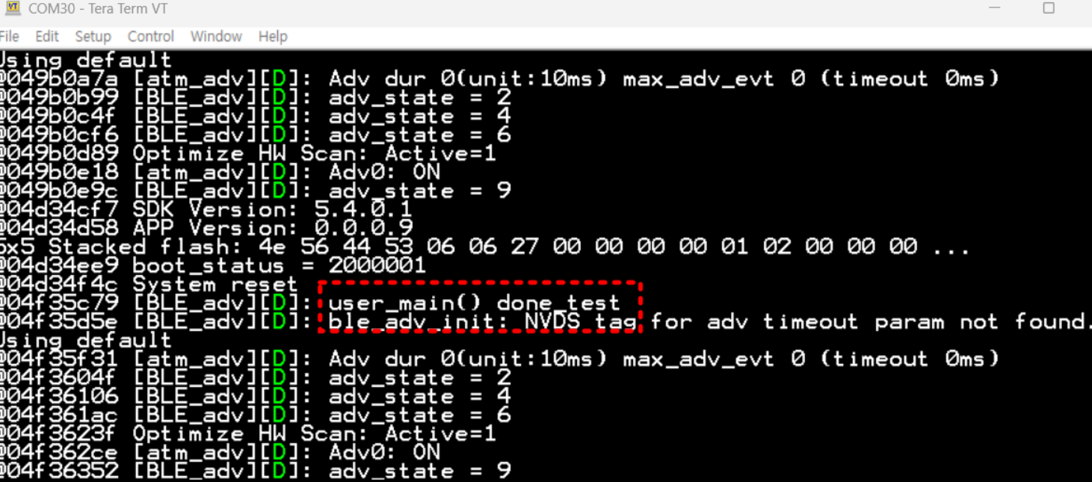
- Select Debug 🡪 Go menu or F5 enter, Click twice
- Break(pause) click
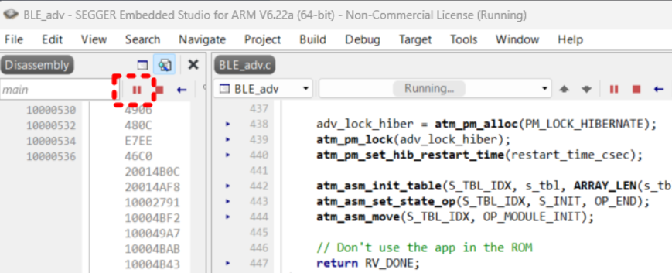
- Choose “core_cmFunc.h” file from :
C:\AtmosicSDK\5.4.0.1\platform\atm2\ATM22xx-x1x\include\arm
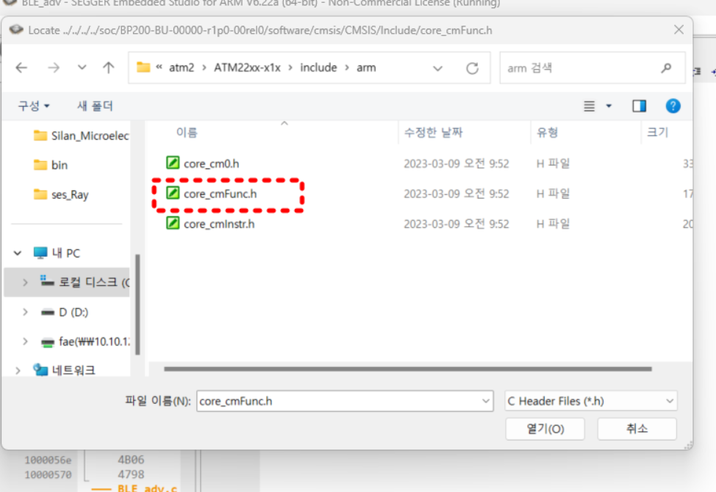

- Choose “reg_blecore.h” file from :
C:\AtmosicSDK\5.4.0.1\platform\atm2\ATM22xx-x1x\include\reg_ble
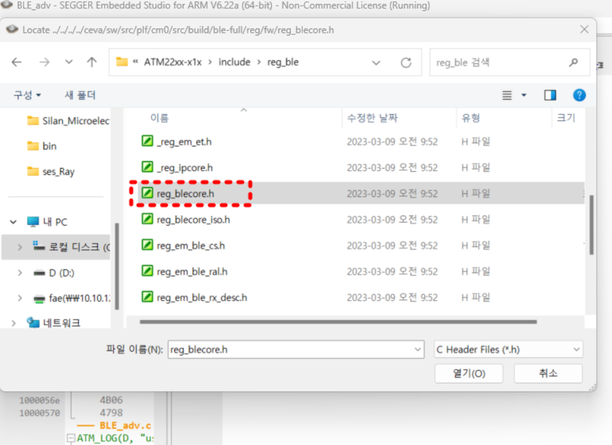
- “debug.c” pop-up window -> cancel(취소) click -> “Can’t find source file”->Yes click
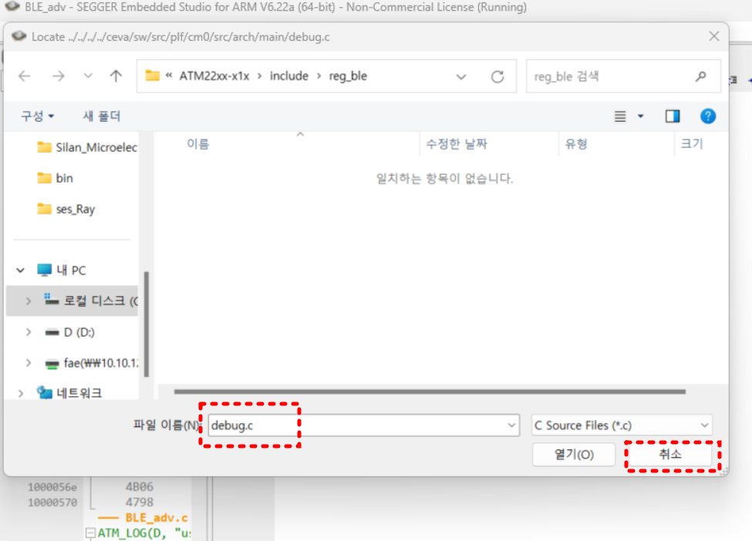

- Break(pause)/Stop function is now available.
- Step into(F11) -> “rep_vec.c” pop-up window -> cancel(취소) click -> “Can’t find source file”->Yes click
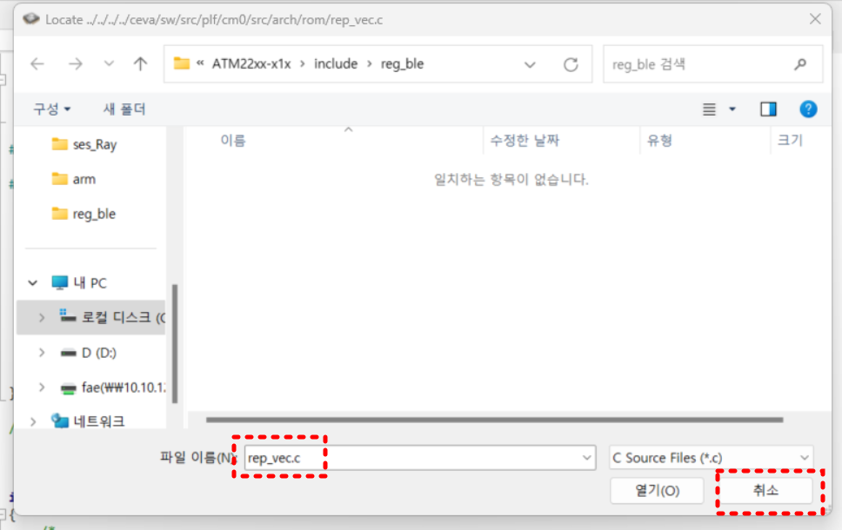
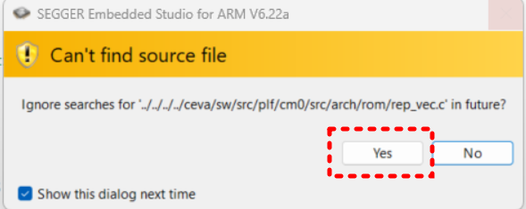
- Choose “stdio.h” file from :
C:\AtmosicSDK\5.4.0.1\tools\gcc-arm-none-eabi-10.3-2021.07\arm-none-eabi\include\ssp
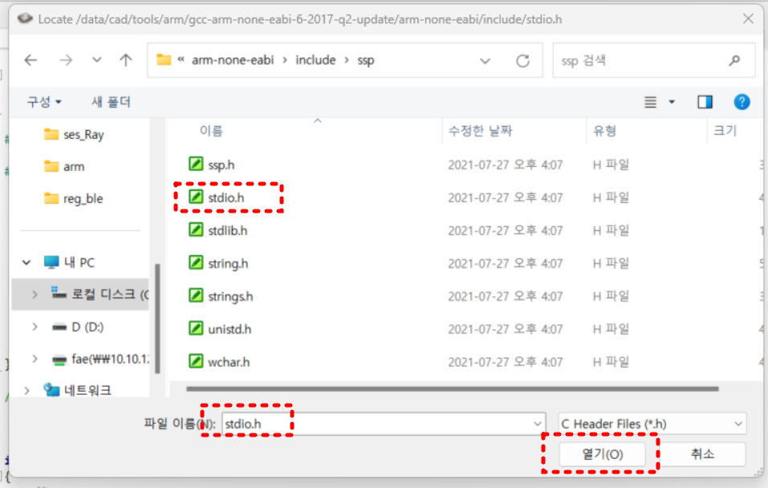

- "Step Into" function operated as shown below.


